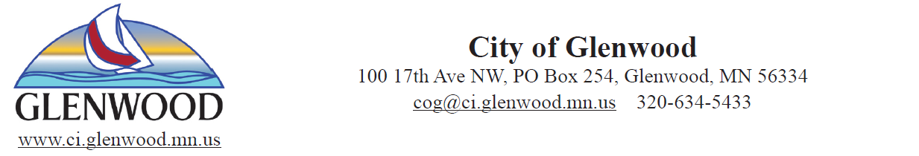
Event Permit Request
Please PRINT legibly when filling out this application.

Sponsoring Organization Event Contact Person

Address Contact Person Phone Number

Organization Phone Number Organization Email Address

Type of Event: (Check all that apply)

Run/Walk | Dance | Fundraiser
Block Party | Planned Demonstration | Celebration
Parade | Ceremony | Other
Street Fair | Concert | Is Alcohol Served?

Date(s) of Event Anticipated Attendance Event Hours (include set up and take down)

Name of Event Time of Event

Location and Description of Event: (List any City parks, streets, trails or facilities to be used and/or blocked-off during the event, and/or how long the street(s) will be blocked off)

NOTE: No permanent markings of route allowed on any streets, sidewalks, or trails in the City of Glenwood.

Print Name: Signature:

Date:

Return form to: City of Glenwood
PO BOX 254
Glenwood, MN
56334

- A map or diagram of the event must be provided and attached (routes, direction of travel, locations of restrooms, serving areas (food, alcohol, stages, fencing, barricades.)

- All the appropriate City Departments will be contacted for their review and comment on this application.

- Street and/or sidewalk closures may require City Commission approval. Please allow lead time prior to your event for placement on the City Commission agenda.

- Applicant is responsible for contacting Gopher State One Call if items are to be driven into the ground.

- The City of Glenwood will not loan out street barricades, cones, or other equipment.

ALL REQUESTS ARE REQUIRED TO BE REVIEWED BY THE FOLLOWING DEPARTMENTS PRIOR TO SUBMITTING TO CITY COUNCIL:

 | Contact/Department | Dept. Initial | Review/Approval
 | Public Works: Comments: |  | Yes No N/A | □
 | Police Department: Comments: |  | Yes No N/A | □
 | Administration: Comments: |  | Yes No N/A | □

Hold Harmless Agreement (Attached) Required: Yes No

Yes No N/A | □

City Council Approval? Date of Next meeting: ___________

Yes No N/A | □
Approved?

Signature: Date:

HOLD HARMLESS AGREEMENT

This Agreement is made and entered into this _____ day of _____________________________, by and between the City of Glenwood, a municipal corporation organized under the laws of the State of Minnesota, hereinafter called “City,” and _____________________________________, hereinafter called “User.”

WHEREAS, User has expressed interest in utilizing City property and/or City facilities for an event as described on Page 1 of this application form.
WHEREAS, upon review of completed Event Permit Request and User’s intent to comply with guidelines set forth in said Request, the City of Glenwood has consented to User’s request.

NOW THEREFORE, in consideration of the mutual promises and conditions hereinafter contained, it is hereby agreed as follows:

- The User understands and agrees that neither the City of Glenwood nor any person acting on behalf of the City shall be held liable in any way for harm, injury, death, property damage, equipment loss or damage as a result of attending or participating in the User’s event.

- The User understands and agrees that the User shall be responsible for any and all repair and/or replacement costs incurred as a result of damage to any City property, buildings, or equipment thereon.

- The User understands and agrees that neither the City of Glenwood nor any person acting on behalf of the City shall be liable in any way for damage to User’s personal property, if any is brought onto City property, or injury caused by wind, rain, hail, or other forces of nature beyond human control.

- The User agrees to abide by the rules and regulations of the City of Glenwood.

IN WITNESS WHEREOF, the City of Glenwood and _____________________________________ (User) have caused this Agreement to be duly executed on the day and year first above written.

CITY OF GLENWOOD USER

By _____________________________________ By ___________________________
City Administrator

Date: ____________________________________________ Date:________________________________

