

**Residential Additions Permit Application**

100 17th Avenue NW

Glenwood, MN 56334

Phone: 320-634-5433

Building Inspector Michael Friedrichs: 320-377-9029

Site Address __________________________________________________ PID # ________________________

Owner(s) _____________________________________________ Daytime Phone _______________________

Owner’s Address (if different from above) _______________________________________________________

Approximate starting date ____________________ Estimated total cost of project $_____________________

Type of Improvement/Addition (Bedroom, living room, garage, etc.): _________________________________

__________________________________________________________________________________________

Describe in detail the work to be done __________________________________________________________

­­­­­­­­­­­­­­­­­­­__________________________________________________________________________________________

Licensed Contractor’s Name _____________________________________ License #_____________________

Contractor’s Phone _________________________________

|  |
| --- |
| Was this dwelling built before 1979? Yes No  If yes, Lead Certification Number ________________________  Lead Certification verified by _________________________________________________________________ |

**If property owner is acting as his/her own general contractor,**

**property owner must sign the Licensed Contractor Disclaimer**

(Additional information required on following page)

Please provide the following, if applicable:

Plumbing Contractor__________________________________________ Phone ________________________

Mason and Concrete Contractor ________________________________ Phone ________________________

Heating and Venting Contractor ________________________________ Phone ________________________

**Required Forms and Items to Return With Application:**

1. **Site Plan**
2. **Full size set of Construction Plans with cross-sections**
3. **One small set of Construction Plans (8 ½ x 11) for file**
4. **Signed Property Disclaimer**

**\*Your Application will be denied until all above items are provided\***

I hereby certify that I have read and examined this application and know the same to be true and correct. All provisions of laws and Ordinances governing this type of work will be complied with, whether specified herein or not. The granting of this permit does not presume to give authority to violate or cancel all the provisions of any other State or local laws regulating construction.

**I have identified all property boundaries, easements, flood zones,**

**and/or wetlands existing on the property on my site plan and application.**

The undersigned further agrees the City of Glenwood and its administrative staff relied on the accurateness of this application, plans, and specification relative to this project and holds the City of Glenwood and its employees harmless from all liability arising from the granting of this permit.

**Signature of Owner or Contractor** ______________________________________________________________

**Zoning Administrator** ________________________________________________________________________

**Public Works Director** _______________________________________________________________________

**Building Official** ____________________________________________________________________________

|  |  |
| --- | --- |
| **For Office Use Only** | |
| **Permit Fee:** | **Permit #:** |
| **Surcharge:** | **Date Rec’d:** |
| **Plan Check:** | **Total Fee:** |

**Property Disclaimer**

The undersigned is the owner of record for the following property located within the City of Glenwood, Pope County, Minnesota, whose address is: _______________________. As part of the process of obtaining a building/zoning permit, the undersigned certifies that all information in the application, plans and specifications are true and correct.

It is the responsibility of the undersigned to identify all property boundaries, easements, and/or wetlands existing on the subject property and identify them on the submitted site plan and application.

The undersigned further agrees that the City of Glenwood, and its administrative staff and agents relied on the accurateness of this application, plans and specifications relative to this project and holds the City of Glenwood and its employees harmless from all liability arising from the granting of this permit.

____________________________________ _________________________

Signature Date

**Utilities Disclaimer**

1. Will you be connecting to Municipal Water?
2. Will you be connecting to Municipal Sewer?
3. Will you be connecting to Municipal Storm Sewer?
4. Will you be excavating in the City right-of-way?
5. What is the intended use for the application?
   * Residential
   * Commercial _____________
   * Industrial ____________
6. Will on acre or more of land be disturbed?
   * If so, a storm water permit must be applied for with the Minnesota Pollution Control Agency. A copy of the MPCA permit must be attached to this form.

____________________________________ _________________________

Signature Date

**If any of the above situations change it is the responsibility of the property owner to notify City Hall.

Notice To All Applicants

A site plan is required with all applications. The site plan should include at minimum:

* Lot Dimensions
* All existing uses and structures within 100 feet of the subject property
* All adjacent streets and alleys
* The dimensions of the proposed footprint of the building with ALL setbacks noted (setbacks include; distance from the property lines, streets and alleys, adjacent structures, ordinary high-water mark, etc. and the structure.)
* All setback requirements are measured to the overhang or outer edge of gutters, not the foundation or sidewall of the building
* Height of side wall, measured from the finished floor elevation to the point at which the sidewall top plate adjoins the rafter
* Height of peek, measured from the finished floor elevation to the top of the peak
* Proposed drainage of storm water run-off away from the proposed structure
* Proposed finished floor elevation of structure

Plans do not need to be professionally drawn but should include all of the information requested. The following sample site plan shows the minimum detail expected so the permit process can proceed smoothly.

**Setback requirements are listed on the next page***

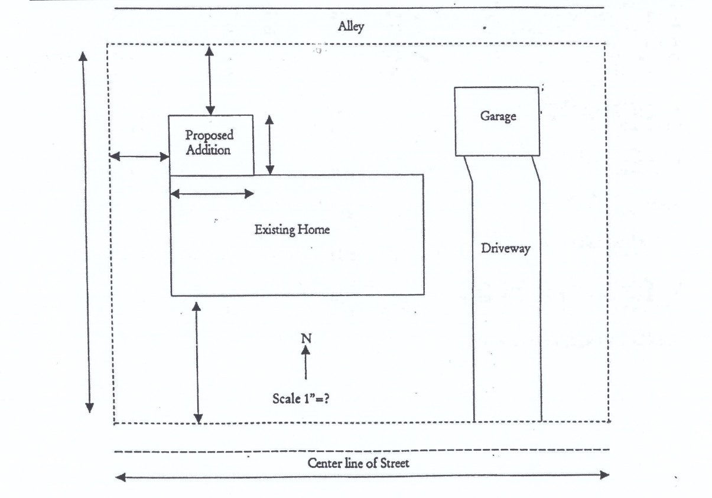

Lot, Yard and Density Requirements

