

**Planning Request Application**

PO Box 254; 100 17th Avenue NW,

Glenwood, MN 56334

Phone: 320-634-5433

Building Inspector: Michael Friedrichs 320-377-9029

Street address of property: ________________________________________ Zoning Dist. ____________

Legal Description: _____________________________________________________________________

___________________________________________________________PID# ____________________

Property Owner

Name: __________________________________ Phone: ____________________________________

Address: _________________________________ City: _________________ State: ____ Zip: ________

Type of Request:

( )Variance ( )Rezoning ( )Conditional Use Permit ( )Plan Review ( )Preliminary Plat ( )Final Plat ( )Other

Description of request __________________________________________________________________

____________________________________________________________________________________

_____________________________________________________________________________________

If this request is for the construction of a structure, a building permit and drawing must also be submitted.

Existing use __________________________________________________________________________

_____________________________________________________________________________________

Is this a permitted use under the current zoning ordinance __ Yes __ No

Has a variance, conditional use permit, or rezoning been applied for previously __Yes __No When_____

If Yes, attach a copy of the conditional use permit, variance, or other document permitting use, or attach an explanation of why the use is permitted.

If and/or when the City is subject to get outside review such as legal, engineering, etc., or there are direct costs for processing the application such as publishing required notices, the costs are billed to the applicant and the applicant, by signing this request agrees to pay such fees.

The undersigned further agrees the City of Glenwood and its administrative staff relied on the accurateness of this application, plans, and specifications relative to this project and holds the City of Glenwood and its employees harmless from all liability arising from the granting of this permit.

___________________________________ __________________

Applicant Signature Date

**FOR OFFICE USE ONLY.**

Permit Fee Schedule:

Permit Fee: $_____________ Date Paid: _____________

Variance Fee: $_____________

Penalty $_____________ Request:

Other $_____________ ___Approved Date: ___________

___Denied

Total Permit Fee: $_____________ Authorized By: _________________

Planning Commission City Commission

Action_____________________________________ Action__________________________________________

__________________________________________ ­­­­­­­­­­­­­­­­­­­_______________________________________________

__________________________________________ _______________________________________________

Signature Date Signature Date

Notice To All Applicants

A site plan is required with all applications. The site plan should include at minimum:

* Lot Dimensions
* All existing uses and structures within 100 feet of the subject property
* All adjacent streets and alleys
* The dimensions of the proposed footprint of the building with ALL setbacks noted (setbacks include; distance from the property lines, streets and alleys, adjacent structures, ordinary high-water mark, etc. and the structure.)
* All setback requirements are measured to the overhang or outer edge of gutters, not the foundation or sidewall of the building
* Height of side wall, measured from the finished floor elevation to the point at which the sidewall top plate adjoins the rafter
* Height of peek, measured from the finished floor elevation to the top of the peak
* Proposed drainage of storm water run-off away from the proposed structure
* Proposed finished floor elevation of structure

Plans do not need to be professionally drawn but should include all of the information requested. The following sample site plan shows the minimum detail expected so the permit process can proceed smoothly.

**Setback requirements are listed on the next page***

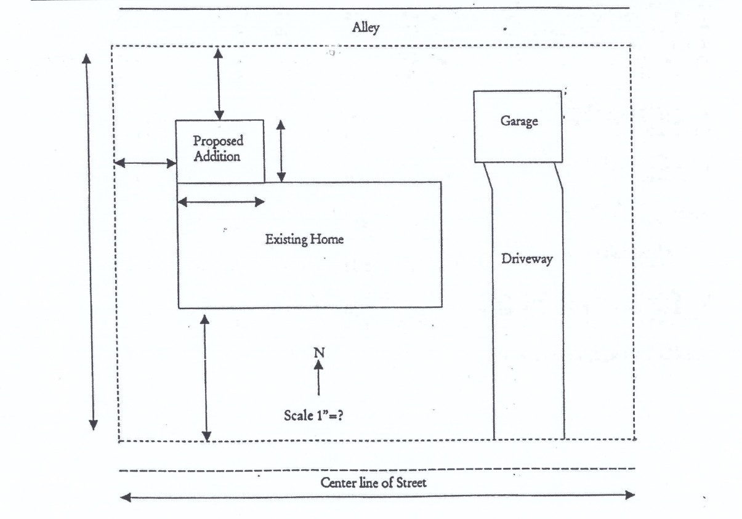

Lot, Yard and Density Requirements

